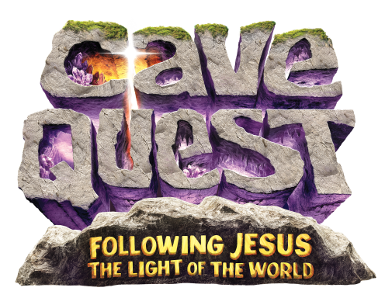
DATES & TIME
Sunday, July 24 – Thursday, July 28, 2016
6:00 p.m. – 8:30 p.m.

Registration Form
(one form per family)
Name(s), Age & Gender:

Street address:

City: State: Zip:

Home telephone: Cell phone:

Home email address:

Number of family members participating in Cave Quest VBS:

Will parents be helping in any other areas of Cave Quest VBS?

Where?

Home church:

Name of special friend your child might like to be with:

T-shirt size/# each: Youth - S M L Adult - S M L Fee: $10/child $20/family
(shirt size not guaranteed after July 8, 2016)

(church use only) Crew name: Paid: Cash/Check
In case of emergency, contact:

Allergies or other medical conditions:

